Text: Looking for The Cat in the Ghat  Duration: 8 days, 50-60 mins per session  Instructional Strategies  - Segmenting and blending through chaining  - Partner reading  - Shared reading with teacher modeling  - Independent reading  - Class discussions  - Learning centers | Word Work Focus:  - Segment and blend CVC and CVCC words  - Read sight words with automaticity in isolation and in context  Comprehension Focus  - Read to infer for deeper meaning  Social-Emotional Focus  - Work with a partner to build shared understanding  - Connect to main ideas about
Materials  - Teacher text  - Student texts  - Red word/sight word cards  - Letter cards for chaining  - Centers materials  - Board and writing utensil  - Blank paper  - Animal cards (images of the animals from the story, cut out)  - Previous lesson charts:  - “We Can ___(Verb)” from ‘What Can Frogs Do?’  - Subject-Verb Agreement from ‘Nap on a Mat’  - Student erasable boards  - Celebration materials | Sight Words Taught:  - about  Text-Specific Vocabulary Taught:  - ghat, hides, trees  Oral Language Practice  - Plural and singular nouns subject-verb agreement  - Using prepositions in speaking and writing  Phonics Skills/Concepts Taught:  - Sounds Right/Looks Right/Makes Sense  Assessment
Follow with Hop Rabbit, Jog Turtle
Looking for the Cat in the Ghat (Stage 2, Day 1)
Time: 50-60 mins
Learning Focus: Decoding CVC and CVCC Words
Skills:
- Segment and decode CVC and CVCC words
- Read sight words in isolation
- Use picture and word part clues to decode
Teacher Preparation
- Letter cards: g, t, s, l, b, e, a, o
- Red Word/Sight Word card ‘about’
- “We Can ___(Verb)” chart from ‘What Can Frogs Do?’
Building Comprehension: Picture Walk (3-5 mins)
In this story, the main characters go searching for a special animal in the ghat. Turn through each page, asking students to share what they notice or wonder.
Word Work: Chaining (5-7 mins)
Take out your magnifying glass, inspectors! These special tools help us look VERY CLOSELY at things. Let's look closely and listen closely as we change around the letters and sounds to read new words.
Arrange the letter cards along the bottom of the board: g, t, s, l, b, e, a, o
Point to each letter card, and have students read the sound aloud.
Display the letter cards for "get". I can tap out this word: /g/-/e/-/t/, get.
Change g to s: What sound? /s/. If that was "get," what word is this? Set. (Students finger-tap and blend if needed.)
Change e to a: What sound? /a/. If that was "set," what word is this? Sat.
Change t to g: What sound? /g/. If that was "sat," what word is this? Sag.
Continue chaining with word list: sag > lag > log > bog > bag.
Word Work: High Frequency Words (5 mins)
Daily focus word: about

Say It/Spell It/Say It routine
Show Red Word card for “about”.
This word is “about.” Say it! Students repeat: about.
Spell it! A-b-o-u-t, about. Students repeat: a-b-o-u-t, about.
Air write it, a-b-o-u-t, about. As you speak, write the letters in the air and say them out loud. When you say the whole word, underline it in the air. Students repeat air-writing.
Show card. Say it! About! Students repeat: About.

Go through Red Word deck, including all previous unit words.
Word Work: Looks Right/Sounds Right/Makes Sense for CVCC Words (10 mins)
—Display the “We Can _____ (Verb)” chart from “What Can Frogs Do?”
—What is a verb? An action word.
—Let’s use our reading skills and investigator skills to find out the verbs in this story.
—Model Looks Right/Sounds Right/Makes Sense: Turn to page 4. I see that this page has an elephant. Read the sentence, skipping over the verb: The elephant…hmm, I don’t know that word. The elephant ____ wet.
—I can tap out part of this word. Tap out and blend /g/-/e/-/t/, get.
—I can add the final sound. I know the final sound is /s/. Get-s, gets.
—I think the verb is “gets.” Does it look right? “Gets” starts with ‘g’ and has a short e. I see that ‘g’ is the first letter and I see ‘e.’
—Does it sound right? Reread the sentence: The elephant gets wet. Yes, it sounds right.
—Does it make sense? I see the elephant cooling off in the water. Yes, it makes sense. The elephant gets wet!
—Add the verb “gets” to the verb chart.
—Guided Practice: Looks Right/Sounds Right/Makes Sense: Turn to page 5.
—What animal do you see? A tiger.
—Read the sentence, skipping over the verb: The tiger ____ in the sun.
—Who can tap out a word part they know in the word? Call on a student to tap and blend /n/-/a/-/p/, nap.
—Who can add the final sound? Call on a student to blend ‘nap-s’, naps.
—I think it is naps. Does it look right? Yes, the word has -ap and starts with /n/.
—Does it sound right? Read the sentence together. Yes!
—Does it make sense? Why? Yes, the tiger looks like it is relaxing and it could sleep soon.
—Add “naps” to the verb chart.
—Display page 7 or 8. Have students try Looks Right/Sounds Right/Makes Sense to sound out the verb with a partner. Add the verb to the verb chart. Read through all of the verbs on the verb chart.
—To read new verbs, we asked: Does it look right? Does it sound right? Does it make sense?

Independent Learning Centers (30 mins)
Monitoring (3-5 mins)
What sight word did we use today?
What reading strategy did we use today?
How will the strategy help us as readers?

Looking for the Cat in the Ghat (Stage 2, Day 2)
Time: 50-60 mins
Learning Focus: Decoding CVC and CVCC Words
Skills:
- Segment and decode CVC and CVCC words
- Read sight words in isolation
- Use picture and word part clues to decode
Teacher Preparation
- Letter cards: h, p, s, m, t, f, b, o, i, a
- Red Word/Sight Word deck
- “Subject-Verb Agreement” chart from ‘Nap on a Mat’
- “We Can ____” verb chart from ‘What Can Frogs Do?’
Building Comprehension (3-5 mins)
What animals do the characters see in the ghat?
Word Work: Chaining (5-7 mins)
Take out your magnifying glass, inspectors! These special tools help us look VERY CLOSELY at things. Let's look closely and listen closely as we change around the letters and sounds to read new words.
Arrange the letter cards along the bottom of the board: h, p, s, m, t, f, b, o, i, a
Display the letter cards for "hops.” I can tap out this word: /h/-/o/-/p/-/s/, hops.
Change h to m: What sound? /m/. If that was "hops," what word is this? Mops.
Change p to t. If that was mops, what words is this? Mots.
Change m to p. If that was “mots,” what words is this? Pots.
Continue with word list: pots > pits > fits > bits > bats
Word Work: High Frequency Words (5 mins)
Flash through all sight words in the sight word deck.

Oral Language Practice: Subject-Verb Agreement (10 mins)
—Display the subject-verb agreement chart from “Nap on a Mat.” Review the -s rule: When we talk about one
animal or person (singular), the verb often ends in "s”.
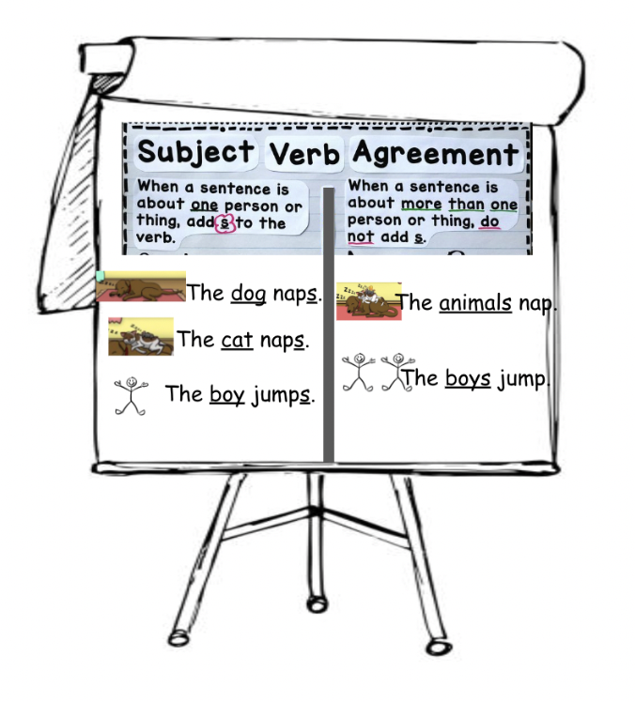
— Display the verb chart. Read through all the verbs on the verb chart as a class.
— You will get into groups of 3. Partner 1 will choose an animal and a verb. Partner 1 will say “The animal _____”. Partners 2 and 3 will respond together, “Two animals _____”.
—Model: Choose two volunteers to come in front of the class. I am partner 1. I choose the elephant. Look at the verb chart and point to a verb. The elephant naps. I am one elephant so I must add ‘-s’.
—Partners 2 and 3, you are two elephants. How should you respond? Two elephants nap. Partners 2 and 3 are more than one, so they do not add ‘-s’ to the verb!
—Model again: Call two more volunteers to the front of the class. I choose a pig. Look at the verb chart. The pig jumps.
—Partners 2 and 3 respond: Two pigs jump!
—Your turn! Get into groups of 3. Partner 1 chooses the animal and the verb. Remember to think of the rule: if you are one animal, add an -s to the verb. If you are more than one, do not add an -s to the verb!
—After group work, challenge students to write a sentence from the activity on their erasable whiteboards:
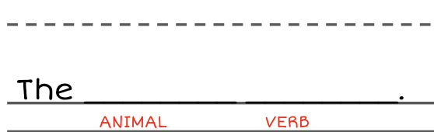
—Walk around and see which students use the correct subject-verb agreement.
Independent Learning Centers (30 mins)
Monitoring
What is a verb?
When do we add an -s to a verb? When do we not add an -s to a verb?

Looking for the Cat in the Ghat (Stage 2, Day 3)
Time: 50-60 mins
Learning Focus: Decoding CVC and CVCC Words
Skills:
- Segment and decode CVC and CVCC words
- Read sight words in isolation and in text
- Use picture and word part clues to decode
- Read to infer deeper meaning
Teacher Preparation
- Letter cards t, ll, h, p, s, c, e, i, a, o
- Student copies of “Cat in the Ghat”
- Teacher copy of “Cat in the Ghat”
- Picture cards of animals from the story
Building Comprehension: Setting the Purpose (3-5 mins)
Readers, we have practiced breaking apart sounds to read words from this book. Today, we will read the book together!

Set the purpose: Reading is thinking! We will read to think about a big question: Why do the animals do what they do?
Word Work: Chaining (5-7 mins)
Take out your magnifying glass, inspectors! These special tools help us look VERY CLOSELY at things. Let's look closely and listen closely as we change around the letters and sounds to read new words.
Arrange the letter cards along the bottom of the board: t, ll, h, p, s, c, e, i, a, o
Display the letter cards for “shell.” I can tap out and blend this word: /t/-/e/-/l/, tell.
Change e to i. What sound? /i/. If that was tell, what word is this? Till.
Change t to h. If that was till, what word is this? Hill.
Change h to p. If that was hill, what word is this? Pill.
Continue with word list: pill > pit > pat > pats > pots > cots > cats.
Word Work: High Frequency Words (5 mins)
Flash through all sight words in the sight word deck.
Oral Language Practice: Prepositions of A Place (10-15 mins)
—Some words tell us where something is. We have practiced these words before.
—Show the cover of “Nap On a Mat. The dog was ____ the mat? On!
—Show page 7 of “What Can Frogs Do?” The frog is ___ the mud? In!
—On chart paper, list “on, in, into”. These are words we have practiced, that tell where something is. Add to the chart: under, next to.
—Read the new prepositions. Demonstrate by going under a desk and next to a desk.
—Hand each student a small object, like the objects used for Elkonin boxes. Review with a few rounds of “Teacher Says”: Teacher says, put it on the desk. Teacher says, put it under the desk. Teacher says, put it next to the desk. Put it in the desk! Students are “out” if they follow the direction that does not start with “Teacher says...”
—Have students work with a partner to draw an image of the story setting: a river, with trees and rocks.
—Pass out animal cards from the story.
—Ask students to place animals in different locations using the prepositions e.g. The animal is on the branch. The animal is under the tree. The animal is next to the river, etc.
Shared Reading (20-30 mins)
Follow Shared Reading routine:
- Go through all red words/sight words. Prompt students to read them with automaticity.
- Go through all “need to know words.” Prompt students to read them with automaticity.
- Remind students: When it’s my turn, I will read. Notice my strategies. When it’s your turn, you try. Remember to use your inside voice or your whisper voice.
- Model reading each page of the text. Segment and blend CVC and CVCC words. Read sight words and “need to know” words with automaticity. Reread each line for fluency.
- Prompt students to read each line with: “your turn.”
Monitoring (5 mins)
What do the animals do? The elephant gets wet, the deer hides, etc.
Turn and talk: Why do you think the animals do what they do? The elephant is hot! The deer is scared of the people!

Looking for the Cat in the Ghat (Stage 2, Day 4)
Time: 50-60 mins
Learning Focus: Decoding CVC and CVCC Words
Skills:
- Segment and decode CVC and CVCC words
- Read sight words in isolation and in text
- Use picture and word part clues to decode
- Read to infer deeper meaning
Teacher Preparation
- “The Cat in the Ghat” student copies
- Chart paper
- Partner Reading anchor chart
Building Comprehension: Setting the Purpose (3-5 mins)
Readers, yesterday we practiced reading “The Cat in the Ghat” together. Today, you will read with your partner!

Set the purpose: Reading is thinking! We will read to think about a big question: Why do the animals do what they do?
Partner Reading (30 mins)
Review partner reading routine: Today, you will read with your partner! As reading partners, you each have a very important job. Sometimes you will listen to your partner as they read the words. You will make sure your partner is pointing to the words as they read, and tapping and blending when they need to. You will congratulate your partner!

Sometimes you will be the reader! You will point to the words as you read. You will make sure to use a clear, inside voice so that your partner can hear you!

Have 2 students come to the front of the class and model partner reading on the first page.
- Partner 1 reads the sentence, tracking the words with their finger.
- Partner 2 helps and restates.
- The partners reread in unison for fluency.
- Partners switch roles on the next page: Partner 2 reads the sentence, tracking the words with their finger.
- Partner 1 helps and restates.
- The partners reread in unison for fluency.

Decoding Behaviors  Students are… | Comprehension  Students understand…
-segmenting and blending to sound out CVCC words  Prompts to support:  -What is the first letter? What sound does it make?  -What is the next letter? What sound does it make?  -What is the final letter? What sound does it make?  -What is this word part? What sounds do these letters make together?  -What happens if you add (sound or letter)? What word is it now?  -What happens if you change (sound or letter) to (sound or letter)? What word is it now?  -recognizing sight words in text  Prompts to support:  -This is one of our red words. Air-write it. Do you remember the red word?  -Show the red word card.  -using Looks Right/Sounds Right/Makes Sense  -Look at the picture. What word makes sense?  -Read the sentence, but skip the word. What word makes sense?  -What is happening on this page? What word makes sense? | -sequencing in the text  -What happened first? What happened next? What happened last?  -What happens in the beginning, middle, and end?  -characters’ choices, thoughts and feelings  -Pages 3-10: What is the character doing? What is the animal doing?  -Are the animals doing the same things or different things? Why?  -Why do you think the animal is doing that?  -Why do you think the character is doing that?
If partners finish reading, prompt them to reread.
Reflection (10 mins)
Wonderful job, partners. Reading is thinking!
Conduct a class discussion. Create a chart on the board. Chart students’ ideas.
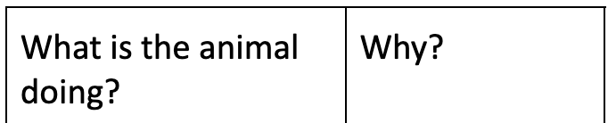

Day 5 | Day 6 | Day 7
—First 10 minutes of class: do a fun whole-class activity.
—Next, divide the class into three equal groups. Groups will work at one of the 3 rotations for 30-40 minutes.
—Last 10 minutes of class: gather in a circle and ask students to reflect on the day. Questions may include:
— Who helped you today? How?
— What is one new thing you learned today?
— What is one way you were challenged today? How did you handle the challenge?
— What went well today? What could have gone better?
—On Days 6 and 7, each group will move to the next rotation.

Rotation 1
Independent —
Vowel Practice Sheets
Students read short-vowel practice stories. Students answer the processing questions individually or with a partner.
Rotation 3
Teacher-Led —
Progress Monitoring
Students read the anchor text individually. The teacher circulates to monitor progress using the assessment checklist.
Rotation 2
Independent — Centers
With partners and in small groups, students work on the unit’s learning centers.

Looking for the Cat in the Ghat (Stage 2, Day 8)
Time: 50-60 mins
Learning Focus: Decoding CVC Words
Skills:
- Reflect on reading skills and strategies in order to celebrate growth as a reader
Teacher Preparation
- One copy of “The Cat in the Ghat”, large enough for student display
- Student copies of “The Cat in the Ghat”
- Celebration Materials
Class Reading (5-10 mins)
Readers, you should be so proud! You have worked hard to read and understand “Cat in the Ghat”! Let’s read together!

Project the text. Call on students to fluently read each page.
Celebration (30 mins)
Today we will celebrate our hard work.

Ways to celebrate reading:
-Community Share: Invite community members into the classroom. This can include caregivers, school staff, or anyone important to students. Have each pair conduct a read-aloud of the text for a community member

-Reading buddies: Connect students with a younger class. Have pairs read aloud the text to their younger schoolmates.

-Create a craft: Use paper bags, popsicle sticks, or any available materials to build animal dens and animal puppets to live in the dens.

-Letter to the author: Write a letter as a class. Include favorite parts, things we learned, and thanks.

-Write a sequel: Work in pairs to make Verb books. On each page, show an animal doing a certain action. Write simple sentences for each page.

-Take a field trip: The human characters use their observation skills to look for the cat in the ghat. Go outside and practice making observations.

-Star ceremony: Each child receives a star in celebration of their reading achievements.
Monitoring (5-10 mins)
What strategies helped you read this book?
How do you feel after reading the book?
What can readers do to celebrate reading?
Why is it important to celebrate reading?

